**Domain of Dataset:** Machine Learning

**Application in the Dataset:** Real-estate

**Name of the Dataset:**

**Source of Dataset:** Kaggle Competitions

**Description of Dataset:**

**Machine Learning Task:** Regression

**Sample Dataset:**

Test.csv

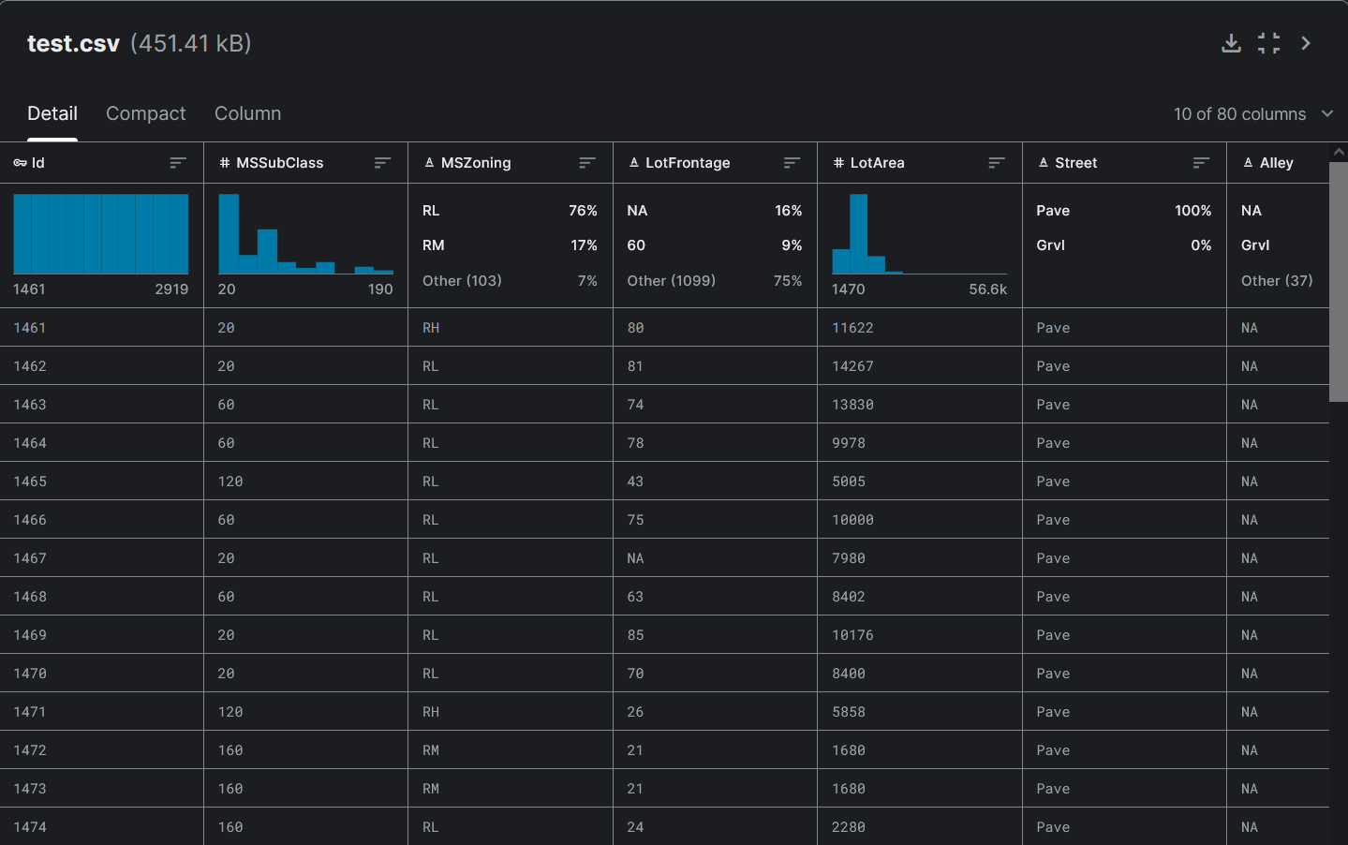

Train.csv

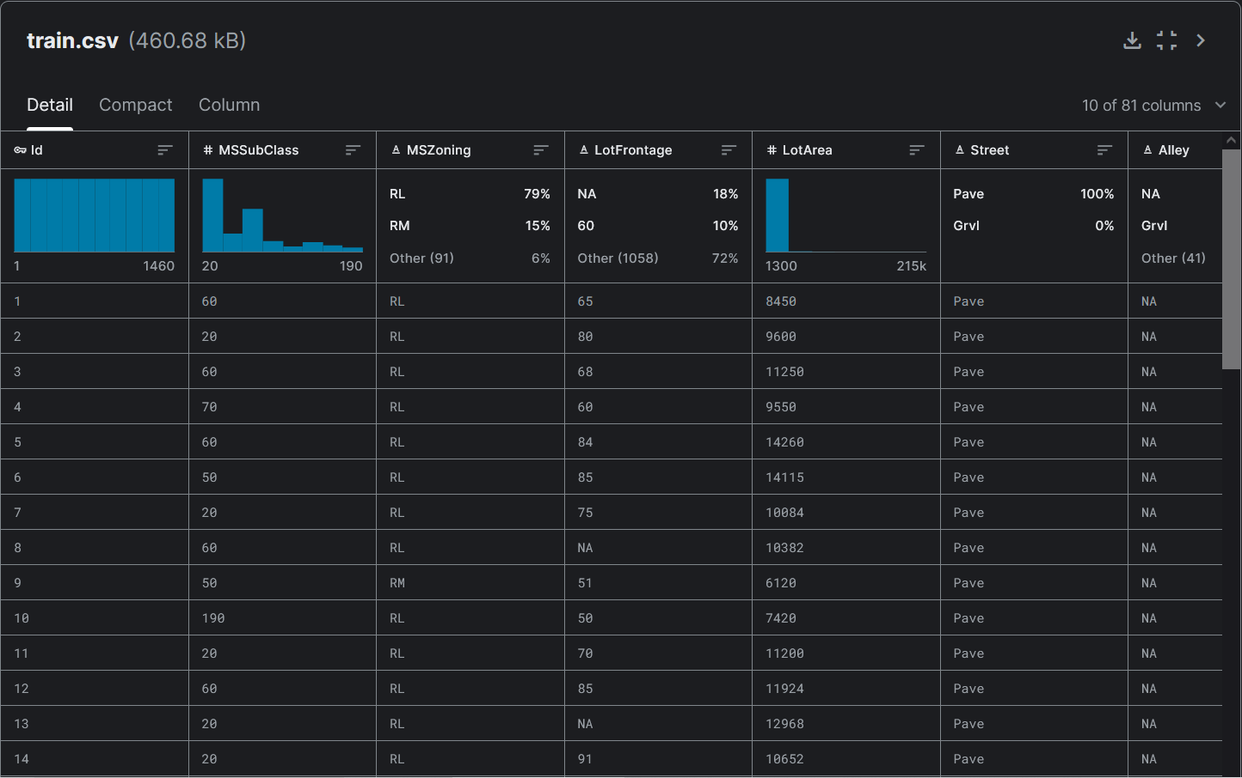

**Download Link:**

https://www.kaggle.com/competitions/house-prices-advanced-regression-techniques/data

**Competition:**

